Examine

https://developers.google.com/drive/v3/web/performance#partial-response

Drive API

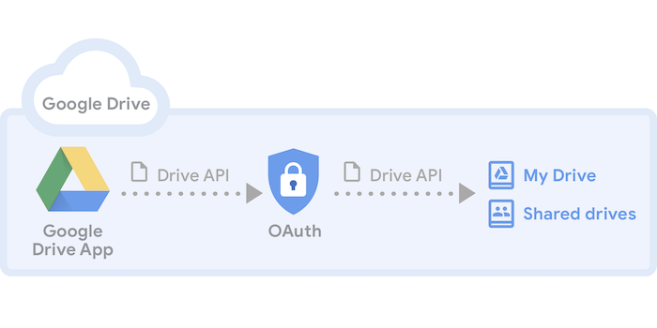

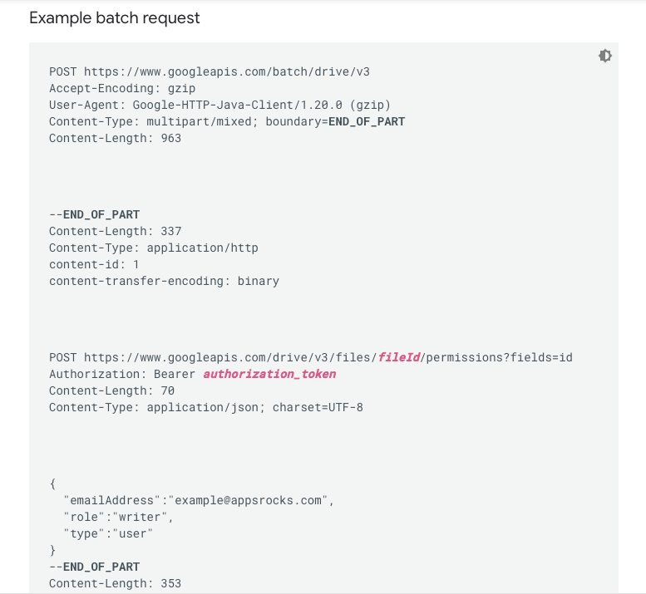

<https://developers.google.com/drive/api/v3/about-sdk>

https://developers.google.com/maps/web-services/overview